# 



LAB NO 2

**Submitted To:**

Engr.Zia Ur Rehman

**Submitted By:**

Muhammad Ibrahim Nasir

**Registration No:**

202101012

**Department:**

BSCE

**Semester:**

7

**Date:**

October 2, 2023

Artificial Intelligence (Lab)

# Artificial Intelligence Lab 02

(Numpy, Pandas, Matplotlib)

# Numpy

## Example 01

### Take 2 lists and multiply both you’ll see that error occurs repeat the process but by coverting them toarray by numpy.array()

In [1]:

l1 **=** [4,4,4]

l2 **=** [5,5,5]

l1**\***l2

**---------------------------------------------------------------------------**

**TypeError** Traceback (most recent call last) Cell **In[1], line 4**

1 l1 = [4,4,4]

2 l2 = [5,5,5]

**----> 4**

**TypeError**: can't multiply sequence by non-int of type 'list'

l1*l2

### Now, by using numpy

In [4]:

**import** numpy **as** np

l1 **=** [1,2,3]

l2 **=** [4,5,6]

A1 **=** np**.**array(l1) A2 **=** np**.**array(l2)

print(f"{A1} * {A2} = {A1**\***A2}")

[1 2 3] * [4 5 6] = [ 4 10 18]

## Example 02

### Demonstrate the use of numpy.dtype and numpy.shape() functions

In [5]:

**import** numpy **as** np

l1 **=** [1,2,3]

l2 **=** [4,5,6]

A1 **=** np**.**array(l1) A2 **=** np**.**array(l2)

A **=** A1**\***A2

print(f"{A1} * {A2} = {A}")

print(f"The type of array using type: {type(A)}")

print(f"The type of array using dtype: {A**.**dtype}") *# no () with dtype because it is a*

print(f"The dimension of an array: {A**.**shape}")

[1 2 3] * [4 5 6] = [ 4 10 18]

The type of array using type: <class 'numpy.ndarray'> The type of array using dtype: int32

The dimension of an array: (3,)

## Example 03

### The size of an array created with numpy.array() is int32 convert it to int 8

In [6]:

**import** numpy **as** np

l1 **=** [1,2,3]

l2 **=** [4,5,6]

A1 **=** np**.**array(l1, np**.**int8) A2 **=** np**.**array(l2, np**.**int8)

A **=** A1**\***A2

print(f"{A1} * {A2} = {A}")

print(f"The type of array using type: {type(A)}")

print(f"The type of array using dtype: {A**.**dtype}") *# no () with dtype because it is a*

print(f"The dimension of an array: {A**.**shape}")

[1 2 3] * [4 5 6] = [ 4 10 18]

The type of array using type: <class 'numpy.ndarray'> The type of array using dtype: int8

The dimension of an array: (3,)

## Example 04

### Demonstrate the use of numpy.size() functions

In [8]:

**import** numpy **as** np

l1 **=** [1,2,3]

l2 **=** [4,5,6]

A1 **=** np**.**array(l1, np**.**int8) A2 **=** np**.**array(l2, np**.**int8)

A **=** A1**\***A2

print(f"{A1} * {A2} = {A}")

print(f"The type of array using type: {type(A)}")

print(f"The type of array using dtype: {A**.**dtype}") *# no () with dtype because it is a*

print(f"The dimension of an array: {A**.**shape}")

print(f"The size of an array: {A**.**size}") *# The size attrubute counts the total elemen*

[1 2 3] * [4 5 6] = [ 4 10 18]

The type of array using type: <class 'numpy.ndarray'> The type of array using dtype: int8

The dimension of an array: (3,) The size of an array: 3

## Example 05

### Create a 2D array using numpy.array()

In [13]:

**import** numpy **as** np

l1 **=** [1,2,3]

l2 **=** [4,5,6]

A **=** np**.**array((l1, l2))

print(f" The 2D array is : \n {A}")

print(f"The type of array using type: {type(A)}")

print(f"The type of array using dtype: {A**.**dtype}") *# no () with dtype because it is a*

print(f"The dimension of an array: {A**.**shape}")

print(f"The size of an array: {A**.**size}") *# The size attrubute counts the total elemen*

The 2D array is :

[[1 2 3]

[4 5 6]]

The type of array using type: <class 'numpy.ndarray'> The type of array using dtype: int32

The dimension of an array: (2, 3) The size of an array: 6

## Example 06

### Create a 1 D array by passing a list

In [15]:

A **=** np**.**array(([1,2,3,4,5]))

print(f" The 1D array is : \n {A}")

print(f"The type of array using type: {type(A)}")

print(f"The type of array using dtype: {A**.**dtype}") *# no () with dtype because it is a*

print(f"The dimension of an array: {A**.**shape}")

print(f"The size of an array: {A**.**size}") *# The size attrubute counts the total elemen*

The 1D array is :

[1 2 3 4 5]

The type of array using type: <class 'numpy.ndarray'> The type of array using dtype: int32

The dimension of an array: (5,) The size of an array: 5

## Example 07

### Create a 2 D array by passing lists

In [18]:

**import** numpy **as** np

A **=** np**.**array(([1,2,3,4,5], [2,3,4,5,6]))

print(f" The 2D array is : \n {A}")

print(f"The type of array using type: {type(A)}")

print(f"The type of array using dtype: {A**.**dtype}") *# no () with dtype because it is a*

print(f"The dimension of an array: {A**.**shape}")

print(f"The size of an array: {A**.**size}") *# The size attrubute counts the total elemen*

The 2D array is :

[[1 2 3 4 5]

[2 3 4 5 6]]

The type of array using type: <class 'numpy.ndarray'> The type of array using dtype: int32

The dimension of an array: (2, 5) The size of an array: 10

## Example 08

### Create 4 x 4 Matrix

In [21]:

**import** numpy **as** np

A **=** np**.**array((r1,r2,r3,r4))

print(f" The array is : \n {A}")

print(f"The type of array using type: {type(A)}")

print(f"The type of array using dtype: {A**.**dtype}") *# no () with dtype because it is a*

|  |  |  |
| --- | --- | --- |
| r1 | **=** | [1,2,3,4] |
| r2 | **=** | [3,6,3,4] |
| r3 | **=** | [1,2,9,4] |
| r4 | **=** | [1,4,5,4] |

print(f"The dimension of an array: {A**.**shape}")

print(f"The size of an array: {A**.**size}") *# The size attrubute counts the total elemen*

The array is :

[[1 2 3 4]

|  |  |  |  |
| --- | --- | --- | --- |
| [3 | 6 | 3 | 4] |
| [1 | 2 | 9 | 4] |
| [1 | 4 | 5 | 4]] |

The type of array using type: <class 'numpy.ndarray'> The type of array using dtype: int32

The dimension of an array: (4, 4)

The size of an array: 16

## Example 09

### Replace 2nd row 3rd element of above 4x4 matrix with 10

In [23]:

**import** numpy **as** np

r1 **=** [1,2,3,4]

r2 **=** [3,6,3,4]

r3 **=** [1,2,9,4]

r4 **=** [1,4,5,4]

A **=** np**.**array((r1,r2,r3,r4))

print(f" The original array is : \n {A}")

A[1,2] **=** 10

print(f" The array after replacing : \n {A}")

The original array is :

[[1 2 3 4]

|  |  |  |  |
| --- | --- | --- | --- |
| [3 | 6 | 3 | 4] |
| [1 | 2 | 9 | 4] |
| [1 | 4 | 5 | 4]] |

The array after replacing :

|  |  |  |  |
| --- | --- | --- | --- |
| [[ | 1 | 2 3 | 4] |
| [ 3 | | 6 10 | 4] |
| [ 1 | | 2 9 | 4] |
| [ 1 | | 4 5 | 4]] |

## Example 10

### Create a 5 x 5 matrix of all zeros by setting values of both rows and column

In [24]:

**import** numpy **as** np

A **=** np**.**zeros([5,5])

print(f" The array is : \n {A}")

print(f"The type of array using type: {type(A)}")

print(f"The type of array using dtype: {A**.**dtype}") *# no () with dtype because it is a*

print(f"The dimension of an array: {A**.**shape}")

print(f"The size of an array: {A**.**size}") *# The size attrubute counts the total elemen*

The array is :

[[0. 0. 0. 0. 0.]

|  |  |  |  |  |
| --- | --- | --- | --- | --- |
| [0. | 0. | 0. | 0. | 0.] |
| [0. | 0. | 0. | 0. | 0.] |
| [0. | 0. | 0. | 0. | 0.] |
| [0. | 0. | 0. | 0. | 0.]] |

The type of array using type: <class 'numpy.ndarray'> The type of array using dtype: float64

The dimension of an array: (5, 5) The size of an array: 25

## Example 11

### Create a 5 x 5 matrix of all zeros by passing only 1 argument

In [29]:

**import** numpy **as** np

A **=** np**.**zeros([5])

print(f" The array is : \n {A}")

print(f"The type of array using type: {type(A)}")

print(f"The type of array using dtype: {A**.**dtype}") *# no () with dtype because it is a*

print(f"The dimension of an array: {A**.**shape}")

print(f"The size of an array: {A**.**size}") *# The size attrubute counts the total elemen*

The array is :

[0. 0. 0. 0. 0.]

The type of array using type: <class 'numpy.ndarray'> The type of array using dtype: float64

The dimension of an array: (5,) The size of an array: 5

## Example 12

### Create an array from 1 to 100 by numpy.arrange()

In [32]:

**import** numpy **as** np

A **=** np**.**arange(1,100)

print(f" The array is : \n {A}")

print(f"The type of array using type: {type(A)}")

print(f"The type of array using dtype: {A**.**dtype}") *# no () with dtype because it is a*

print(f"The dimension of an array: {A**.**shape}")

print(f"The size of an array: {A**.**size}") *# The size attrubute counts the total elemen*

The array is :

[ 1 2 3 4 5 6 7 8 9 10 11 12 13 14 15 16 17 18 19 20 21 22 23 24

|  |  |  |  |  |  |  |  |  |  |  |  |  |  |  |  |  |  |  |  |  |  |  |  |
| --- | --- | --- | --- | --- | --- | --- | --- | --- | --- | --- | --- | --- | --- | --- | --- | --- | --- | --- | --- | --- | --- | --- | --- |
| 25 | 26 | 27 | 28 | 29 | 30 | 31 | 32 | 33 | 34 | 35 | 36 | 37 | 38 | 39 | 40 | 41 | 42 | 43 | 44 | 45 | 46 | 47 | 48 |
| 49 | 50 | 51 | 52 | 53 | 54 | 55 | 56 | 57 | 58 | 59 | 60 | 61 | 62 | 63 | 64 | 65 | 66 | 67 | 68 | 69 | 70 | 71 | 72 |
| 73 | 74 | 75 | 76 | 77 | 78 | 79 | 80 | 81 | 82 | 83 | 84 | 85 | 86 | 87 | 88 | 89 | 90 | 91 | 92 | 93 | 94 | 95 | 96 |
| 97 | 98 | 99] |  |  |  |  |  |  |  |  |  |  |  |  |  |  |  |  |  |  |  |  |  |

The type of array using type: <class 'numpy.ndarray'> The type of array using dtype: int32

The dimension of an array: (99,) The size of an array: 99

## Example 13

### Create an array from 1 to 100 by numpy.arrange() with a stepsize of 10

In [33]:

**import** numpy **as** np

A **=** np**.**arange(1,100,10)

print(f" The array is : \n {A}")

print(f"The type of array using type: {type(A)}")

print(f"The type of array using dtype: {A**.**dtype}") *# no () with dtype because it is a*

print(f"The dimension of an array: {A**.**shape}")

print(f"The size of an array: {A**.**size}") *# The size attrubute counts the total elemen*

The array is :

[ 1 11 21 31 41 51 61 71 81 91]

The type of array using type: <class 'numpy.ndarray'> The type of array using dtype: int32

The dimension of an array: (10,) The size of an array: 10

## Example 14

### Create an array of 100 elements ranging from 2 to 3

In [34]:

**import** numpy **as** np

A **=** np**.**linspace(2,3,100)

print(f" The array is : \n {A}")

print(f"The type of array using type: {type(A)}")

print(f"The type of array using dtype: {A**.**dtype}") *# no () with dtype because it is a*

print(f"The dimension of an array: {A**.**shape}")

print(f"The size of an array: {A**.**size}") *# The size attrubute counts the total elemen*

The array is :

[2. 2.01010101 2.02020202 2.03030303 2.04040404 2.05050505

|  |  |  |  |  |  |
| --- | --- | --- | --- | --- | --- |
| 2.06060606 | 2.07070707 | 2.08080808 | 2.09090909 | 2.1010101 | 2.11111111 |
| 2.12121212 | 2.13131313 | 2.14141414 | 2.15151515 | 2.16161616 | 2.17171717 |
| 2.18181818 | 2.19191919 | 2.2020202 | 2.21212121 | 2.22222222 | 2.23232323 |
| 2.24242424 | 2.25252525 | 2.26262626 | 2.27272727 | 2.28282828 | 2.29292929 |
| 2.3030303 | 2.31313131 | 2.32323232 | 2.33333333 | 2.34343434 | 2.35353535 |
| 2.36363636 | 2.37373737 | 2.38383838 | 2.39393939 | 2.4040404 | 2.41414141 |
| 2.42424242 | 2.43434343 | 2.44444444 | 2.45454545 | 2.46464646 | 2.47474747 |
| 2.48484848 | 2.49494949 | 2.50505051 | 2.51515152 | 2.52525253 | 2.53535354 |
| 2.54545455 | 2.55555556 | 2.56565657 | 2.57575758 | 2.58585859 | 2.5959596 |
| 2.60606061 | 2.61616162 | 2.62626263 | 2.63636364 | 2.64646465 | 2.65656566 |
| 2.66666667 | 2.67676768 | 2.68686869 | 2.6969697 | 2.70707071 | 2.71717172 |
| 2.72727273 | 2.73737374 | 2.74747475 | 2.75757576 | 2.76767677 | 2.77777778 |
| 2.78787879 | 2.7979798 | 2.80808081 | 2.81818182 | 2.82828283 | 2.83838384 |
| 2.84848485 | 2.85858586 | 2.86868687 | 2.87878788 | 2.88888889 | 2.8989899 |
| 2.90909091 | 2.91919192 | 2.92929293 | 2.93939394 | 2.94949495 | 2.95959596 |
| 2.96969697 | 2.97979798 | 2.98989899 | 3. ] | |  |

The type of array using type: <class 'numpy.ndarray'> The type of array using dtype: float64

The dimension of an array: (100,) The size of an array: 100

## Example 15

### Create identity matrix

In [35]:

**import** numpy **as** np

A **=** np**.**identity(5)

print(f" The array is : \n {A}")

print(f"The type of array using type: {type(A)}")

print(f"The type of array using dtype: {A**.**dtype}") *# no () with dtype because it is a*

print(f"The dimension of an array: {A**.**shape}")

print(f"The size of an array: {A**.**size}") *# The size attrubute counts the total elemen*

The array is :

[[1. 0. 0. 0. 0.]

|  |  |  |  |  |
| --- | --- | --- | --- | --- |
| [0. | 1. | 0. | 0. | 0.] |
| [0. | 0. | 1. | 0. | 0.] |
| [0. | 0. | 0. | 1. | 0.] |
| [0. | 0. | 0. | 0. | 1.]] |

The type of array using type: <class 'numpy.ndarray'> The type of array using dtype: float64

The dimension of an array: (5, 5) The size of an array: 25

## Example 16

### Create a 4 x 4 matrix and find the sum of all columns

In [37]:

**import** numpy **as** np

r1 **=** [1,2,3,4]

r2 **=** [3,6,3,4]

r3 **=** [1,2,9,4]

r4 **=** [1,4,5,4]

A **=** np**.**array((r1,r2,r3,r4))

print(f" The Matrix is : \n {A}")

print(f" The row wise sum is : {A**.**sum(axis**=**1)}")

print(f" The column wise sum is : {A**.**sum(axis**=**0)}")

print(f"The type of array using type: {type(A)}")

print(f"The type of array using dtype: {A**.**dtype}") *# no () with dtype because it is a*

print(f"The dimension of an array: {A**.**shape}")

print(f"The size of an array: {A**.**size}") *# The size attrubute counts the total elemen*

The Matrix is :

[[1 2 3 4]

|  |  |  |  |
| --- | --- | --- | --- |
| [3 | 6 | 3 | 4] |
| [1 | 2 | 9 | 4] |
| [1 | 4 | 5 | 4]] |

The row wise sum is : [10 16 16 14]

The column wise sum is : [ 6 14 20 16]

The type of array using type: <class 'numpy.ndarray'> The type of array using dtype: int32

The dimension of an array: (4, 4) The size of an array: 16

## Example 17

### Find the transpose of a Matrix

In [38]:

**import** numpy **as** np

r1 **=** [1,2,3,4]

r2 **=** [3,6,3,4]

r3 **=** [1,2,9,4]

r4 **=** [1,4,5,4]

A **=** np**.**array((r1,r2,r3,r4))

print(f" The Matrix is : \n {A}")

print(f" The transpose is : \n {A**.**T}")

The Matrix is : [[1 2 3 4]

|  |  |  |  |
| --- | --- | --- | --- |
| [3 | 6 | 3 | 4] |
| [1 | 2 | 9 | 4] |
| [1 | 4 | 5 | 4]] |

The transpose is : [[1 3 1 1]

|  |  |  |  |
| --- | --- | --- | --- |
| [2 | 6 | 2 | 4] |
| [3 | 3 | 9 | 5] |
| [4 | 4 | 4 | 4]] |

## Example 18

### Use reshape command to convrt 4 x 4 matrix to 8 x 2

In [41]:

**import** numpy **as** np

r1 **=** [1,2,3,4]

r2 **=** [3,6,3,4]

r3 **=** [1,2,9,4]

r4 **=** [1,4,5,4]

A **=** np**.**array((r1,r2,r3,r4))

print(f" The 4x4 Matrix is : \n {A}")

print(f" The 8x2 matrix: \n {A**.**reshape(8,2)}")

The 4x4 Matrix is :

[[1 2 3 4]

|  |  |  |  |
| --- | --- | --- | --- |
| [3 | 6 | 3 | 4] |
| [1 | 2 | 9 | 4] |
| [1 | 4 | 5 | 4]] |

The 8x2 matrix:

[[1 2]

|  |  |
| --- | --- |
| [3 | 4] |
| [3 | 6] |
| [3 | 4] |
| [1 | 2] |
| [9 | 4] |
| [1 | 4] |
| [5 | 4]] |

## Example 19

### Demonstrate the use of numpy.ravel()

In [43]:

**import** numpy **as** np

r1 **=** [1,2,3,4]

r2 **=** [3,6,3,4]

r3 **=** [1,2,9,4]

r4 **=** [1,4,5,4]

A **=** np**.**array((r1,r2,r3,r4))

print(f" The 4x4 Matrix is : \n {A}")

print(f" The 1D array from above matrix using ravel: \n {A**.**ravel()}")

The 4x4 Matrix is :

[[1 2 3 4]

|  |  |  |  |
| --- | --- | --- | --- |
| [3 | 6 | 3 | 4] |
| [1 | 2 | 9 | 4] |
| [1 | 4 | 5 | 4]] |

The 1D array from above matrix using ravel: [1 2 3 4 3 6 3 4 1 2 9 4 1 4 5 4]

## Example 20

### Demonstrate the use of argmax, argmin,argsort

In [44]:

**import** numpy **as** np a **=** [1, 16, 31, 4]

A **=** np**.**array(a)

print(f"The original array: {A}")

print(f"The index of maximum value in array is: {A**.**argmax()}") print(f"The index of minimum value in array is: {A**.**argmin()}") print(f"Sorted Indexes: {A**.**argsort()}")

The original array: [ 1 16 31 4]

The index of maximum value in array is: 2 The index of minimum value in array is: 0 Sorted Indexes: [0 3 1 2]

## Example 21

### Demostrate the use of numpy.full(),vstack(),hstack(),column_stack()

In [3]:

**import** numpy **as** np

f1**=**np**.**full((2,2),5) f1

Out[3]:

In [4]:

array([[5, 5],

[5, 5]])

f2 **=** np**.**full((2,2), 3) f2

Out[4]:

In [6]:

array([[3, 3],

[3, 3]])

a **=** np**.**vstack([f1, f2]) a

Out[6]:

|  |  |
| --- | --- |
| array([[5, | 5], |
| [5, | 5], |
| [3, | 3], |
| [3, | 3]]) |

In [7]:

b **=** np**.**hstack([f1, f2]) b

Out[7]:

In [8]:

array([[5, 5, 3, 3],

[5, 5, 3, 3]])

a **=** np**.**column_stack([f1, f2]) a

Out[8]:

array([[5, 5, 3, 3],

[5, 5, 3, 3]])

## Example 22

### Save and load a matrix in the memory

In [9]:

**import** numpy **as** np

a **=** np**.**full((2,3), 5) a

Out[9]:

In [10]:

array([[5, 5, 5],

[5, 5, 5]])

np**.**save("untitled.npy", a)

In [11]:

savedMatrix **=** np**.**load('untitled.npy') savedMatrix

Out[11]:

In [12]:

array([[5, 5, 5],

[5, 5, 5]])

## Example 23

### Demonstrate the use of numoy.dot() and compare it with simple multiplication

f1 =

**import** numpy **as** np

f1**=**np**.** full((2,2),5) print("\nf1 = \n",f1)

f2**=**np**.**full((2,2), 3)

print("\nf2 = \n", f2)

print("point to point multiplication = ",f1**\***f2)

print("point to point multiplication = ", np**.**dot(f1,f2))

[[5 5]

[5 5]]

f2 =

[[3 3]

[3 3]]

point to point multiplication = [[15 15] [15 15]]

point to point multiplication = [[30 30] [30 30]]

# Pandas

## Example 01

### Create a Dictionary and convert them into data frames also check its datatype

In [14]:

*#create a dictionary*

StuDict**=**{"Name": ["Aqsa","Esha", "Ayesha", "Ayra", "Arfa", "Afsa", "Abdul", "Saadia",

"ID": ["SID-1","SID-2", "SID-3", "SID-4", "SID-5","SID-6", "SID-7", "SID-8", "SID-9", "Rol1_no": [1,2,3,4,5,6,7,8,9,10],

"Semester" : [7,7,7,7,6,6,6,5,8,8]}

StuDict

Out[14]:

In [16]:

{'Name': ['Aqsa', 'Esha',

'Ayesha',

'Ayra',

'Arfa',

'Afsa',

'Abdul',

'Saadia',

'Abu Bakar', 'Atif'],

'ID': ['SID-1',

'SID-2',

'SID-3',

'SID-4',

'SID-5',

'SID-6',

'SID-7',

'SID-8',

'SID-9',

'SID-10'],

'Rol1_no': [1, 2, 3, 4, 5, 6, 7, 8, 9, 10],

'Semester': [7, 7, 7, 7, 6, 6, 6, 5, 8, 8]}

*#convert into data frames*

**import** pandas **as** pd

data**=**pd**.**DataFrame (StuDict) print(data)

print("\n\nThe data type of above given syntax is :",type (data))

Name ID Rol1_no Semester

1. Aqsa SID-1 1 7
2. Esha SID-2 2 7
3. Ayesha SID-3 3 7
4. Ayra SID-4 4 7
5. Arfa SID-5 5 6
6. Afsa SID-6 6 6
7. Abdul SID-7 7 6
8. Saadia SID-8 8 5
9. Abu Bakar SID-9 9 8
10. Atif SID-10 10 8

The data type of above given syntax is : <class 'pandas.core.frame.DataFrame'>

## Example 02

### Demonstrate the use of describe function for a data frame

In [21]:

print(data**.**describe())

|  |  |  |
| --- | --- | --- |
| count | Rol1_no  10.00000 | Semester  10.000000 |
| mean | 5.50000 | 6.700000 |
| std | 3.02765 | 0.948683 |
| min | 1.00000 | 5.000000 |
| 25% | 3.25000 | 6.000000 |
| 50% | 5.50000 | 7.000000 |
| 75% | 7.75000 | 7.000000 |
| max | 10.00000 | 8.000000 |

## Example 03

### Demonstrate the use of head function for a data frame

In [22]:

print(data**.**head())

Name ID Rol1_no Semester

1. Aqsa SID-1 1 7
2. Esha SID-2 2 7
3. Ayesha SID-3 3 7
4. Ayra SID-4 4 7
5. Arfa SID-5 5 6

Example 04

Demonstrate the use of tail function for a data frame

In [23]:

print(data**.**tail())

Name ID Rol1_no Semester

1. Afsa SID-6 6 6
2. Abdul SID-7 7 6
3. Saadia SID-8 8 5
4. Abu Bakar SID-9 9 8
5. Atif SID-10 10 8

## Example 05

### Demonstrate the use of info function for a data frame

In [24]:

print(data**.**info())

<class 'pandas.core.frame.DataFrame'> RangeIndex: 10 entries, 0 to 9

Data columns (total 4 columns):

# Column Non-Null Count Dtype

|  |  |  |  |  |  |  |
| --- | --- | --- | --- | --- | --- | --- |
| 0 |  | Name | 10 | non-null |  | object |
| 1 |  | ID | 10 | non-null |  | object |
| 2 |  | Rol1_no | 10 | non-null |  | int64 |
| 3 |  | Semester | 10 | non-null |  | int64 |

dtypes: int64(2), object(2) memory usage: 448.0+ bytes None

## Example 06

### Convert the data frame in a variable to CSV file

In [25]:

data**.**to_csv('student.csv')

## Example 07

### Remove the indexes from the csv file

In [27]:

data**.**to_csv('Without_index.csv', index**=False**)

## Example 08

### Read from csv file

In [28]:

df **=** pd**.**read_csv('student.csv') df

|  |  |  |  |  |  |  |
| --- | --- | --- | --- | --- | --- | --- |
| Out[28]: |  | **Unnamed: 0** | **Name** | **ID** | **Rol1_no** | **Semester** |
|  | **0** | 0 | Aqsa | SID-1 | 1 | 7 |
|  | **1** | 1 | Esha | SID-2 | 2 | 7 |
|  | **2** | 2 | Ayesha | SID-3 | 3 | 7 |
|  | **3** | 3 | Ayra | SID-4 | 4 | 7 |
|  | **4** | 4 | Arfa | SID-5 | 5 | 6 |
|  | **5** | 5 | Afsa | SID-6 | 6 | 6 |
|  | **6** | 6 | Abdul | SID-7 | 7 | 6 |
|  | **7** | 7 | Saadia | SID-8 | 8 | 5 |
|  | **8** | 8 | Abu Bakar | SID-9 | 9 | 8 |
|  | **9** | 9 | Atif | SID-10 | 10 | 8 |

## Example 09

### Use describe,head,tail and info function for CSV file

In [1]:

**import** pandas **as** pd

df **=** pd**.**read_csv('student.csv')

print(f"Describe Function \n {df**.**describe()}, \n head Function \n {df**.**head()} \n tail print(f"\n info Function \n {df**.**info()}")

Describe Function

|  |  |  |  |  |
| --- | --- | --- | --- | --- |
|  | Unnamed: | 0 | Rol1_no | Semester |
| count | 10.00000 |  | 10.00000 | 10.000000 |
| mean | 4.50000 |  | 5.50000 | 6.700000 |
| std | 3.02765 |  | 3.02765 | 0.948683 |
| min | 0.00000 |  | 1.00000 | 5.000000 |
| 25% | 2.25000 |  | 3.25000 | 6.000000 |
| 50% | 4.50000 |  | 5.50000 | 7.000000 |
| 75% | 6.75000 |  | 7.75000 | 7.000000 |
| max | 9.00000 |  | 10.00000 | 8.000000, |
| head | Function |  |  |  |

Unnamed: 0 Name ID Rol1_no Semester

1. 0 Aqsa SID-1 1 7
2. 1 Esha SID-2 2 7
3. 2 Ayesha SID-3 3 7
4. 3 Ayra SID-4 4 7
5. 4 Arfa SID-5 5 6

tail Function

Unnamed: 0 Name ID Rol1_no Semester

1. 5 Afsa SID-6 6 6
2. 6 Abdul SID-7 7 6
3. 7 Saadia SID-8 8 5
4. 8 Abu Bakar SID-9 9 8

9 9 Atif SID-10 10 8

<class 'pandas.core.frame.DataFrame'> RangeIndex: 10 entries, 0 to 9

Data columns (total 5 columns):

# Column Non-Null Count Dtype

|  |  |  |  |  |  |  |  |
| --- | --- | --- | --- | --- | --- | --- | --- |
| 0 |  | Unnamed: | 0 | 10 | non-null |  | int64 |
| 1 |  | Name |  | 10 | non-null |  | object |
| 2 |  | ID |  | 10 | non-null |  | object |
| 3 |  | Rol1_no |  | 10 | non-null |  | int64 |
| 4 |  | Semester |  | 10 | non-null |  | int64 |

dtypes: int64(3), object(2) memory usage: 528.0+ bytes

info Function None

## Example 10

### Access a column by its name

In [2]:

**import** pandas **as** pd

df['Name']

Out[2]:

1. Aqsa
2. Esha
3. Ayesha
4. Ayra
5. Arfa
6. Afsa
7. Abdul
8. Saadia
9. Abu Bakar
10. Atif

Name: Name, dtype: object

## Example 11

### Access the 1st element of a column

In [3]:

Out[3]:

'Aqsa'

df['Name'][0]

## Example 12

### Update the value in the column

In [4]:

df['Name'][0] **=** 'Saddam' df

C:\Users\hp\AppData\Local\Temp\ipykernel_17156\2832195598.py:1: SettingWithCopyWarnin g:

A value is trying to be set on a copy of a slice from a DataFrame

See the caveats in the documentation: https://pandas.pydata.org/pandas-docs/stable/us er_guide/indexing.html#returning-a-view-versus-a-copy

df['Name'][0] = 'Saddam'

|  |  |  |  |  |  |  |
| --- | --- | --- | --- | --- | --- | --- |
| Out[4]: |  | **Unnamed: 0** | **Name** | **ID** | **Rol1_no** | **Semester** |
|  | **0** | 0 | Saddam | SID-1 | 1 | 7 |
|  | **1** | 1 | Esha | SID-2 | 2 | 7 |
|  | **2** | 2 | Ayesha | SID-3 | 3 | 7 |
|  | **3** | 3 | Ayra | SID-4 | 4 | 7 |
|  | **4** | 4 | Arfa | SID-5 | 5 | 6 |
|  | **5** | 5 | Afsa | SID-6 | 6 | 6 |
|  | **6** | 6 | Abdul | SID-7 | 7 | 6 |
|  | **7** | 7 | Saadia | SID-8 | 8 | 5 |
|  | **8** | 8 | Abu Bakar | SID-9 | 9 | 8 |
|  | **9** | 9 | Atif | SID-10 | 10 | 8 |

## Example 13

### Find the columns and indexes in a data frame

In [5]:

Out[5]:

In [6]:

Out[6]:

Index(['Unnamed: 0', 'Name', 'ID', 'Rol1_no', 'Semester'], dtype='object')

df**.**columns

df**.**index

RangeIndex(start=0, stop=10, step=1)

## Example 14

### Create a series of 50 random numbers and check their data type and shape

In [9]:

**import** pandas **as** pd

**import** numpy **as** np

s **=** pd**.**Series(np**.**random**.**rand(50)) print(s)

print(f"Using dtype: {s**.**dtype}")

print(f"Using type: {type(s)}") print(f"Using Shape: {s**.**shape}")

|  |  |
| --- | --- |
| 0 | 0.213985 |
| 1 | 0.705265 |
| 2 | 0.355021 |
| 3 | 0.522076 |
| 4 | 0.945126 |
| 5 | 0.889899 |
| 6 | 0.153129 |
| 7 | 0.923423 |
| 8 | 0.569371 |
| 9 | 0.036794 |
| 10 | 0.021892 |
| 11 | 0.968794 |
| 12 | 0.095629 |
| 13 | 0.690430 |
| 14 | 0.658842 |
| 15 | 0.227521 |
| 16 | 0.239709 |
| 17 | 0.993304 |
| 18 | 0.864950 |
| 19 | 0.362236 |
| 20 | 0.439025 |
| 21 | 0.898234 |
| 22 | 0.198995 |
| 23 | 0.713161 |
| 24 | 0.456129 |
| 25 | 0.526069 |
| 26 | 0.498385 |
| 27 | 0.838366 |
| 28 | 0.958630 |
| 29 | 0.812052 |
| 30 | 0.245112 |
| 31 | 0.874729 |
| 32 | 0.440818 |
| 33 | 0.563841 |
| 34 | 0.456232 |
| 35 | 0.523567 |
| 36 | 0.637054 |
| 37 | 0.036077 |
| 38 | 0.326362 |
| 39 | 0.511615 |
| 40 | 0.242937 |
| 41 | 0.787437 |
| 42 | 0.764949 |
| 43 | 0.166757 |
| 44 | 0.842915 |
| 45 | 0.685571 |
| 46 | 0.902296 |
| 47 | 0.889085 |
| 48 | 0.832561 |
| 49 | 0.093487 |

dtype: float64

Using dtype: float64

Using type: <class 'pandas.core.series.Series'> Using Shape: (50,)

## Example 15

### Create a 50 x 5 data set from random values

In [12]:

**import** pandas **as** pd

**import** numpy **as** np

dataf **=** pd**.**DataFrame(np**.**random**.**rand(50,5)) print(s)

0 1 2 3 4

0 0.095117 0.639494 0.662132 0.377261 0.484351

1 0.619275 0.943618 0.842647 0.882023 0.789404

2 0.341192 0.423504 0.457024 0.182026 0.034171

3 0.341754 0.709385 0.585795 0.407479 0.102380

4 0.068927 0.212324 0.611905 0.775162 0.103636

5 0.847370 0.306612 0.444425 0.632644 0.659969

6 0.317868 0.846814 0.728211 0.204996 0.125151

7 0.790399 0.043253 0.376310 0.094241 0.215075

8 0.136808 0.813166 0.611163 0.436034 0.227827

9 0.196890 0.428134 0.534169 0.007336 0.372561

10 0.993245 0.883609 0.091237 0.928452 0.020587

11 0.535516 0.687310 0.810303 0.787431 0.318259

12 0.602856 0.067509 0.395043 0.777689 0.543671

13 0.728186 0.257312 0.067979 0.815434 0.677408

14 0.911252 0.149094 0.898748 0.514953 0.545707

15 0.202250 0.901579 0.828142 0.552332 0.841038

16 0.918471 0.168144 0.495997 0.994389 0.854160

17 0.158534 0.908556 0.026688 0.575473 0.382548

18 0.759819 0.625431 0.845625 0.496324 0.368966

19 0.661029 0.160153 0.874547 0.206498 0.644983

20 0.810375 0.390970 0.306229 0.676295 0.722247

21 0.539418 0.330170 0.877379 0.271891 0.246110

22 0.211602 0.603702 0.120888 0.673845 0.652311

23 0.464343 0.657081 0.223643 0.240461 0.137519

24 0.236285 0.591518 0.631231 0.930020 0.405097

25 0.146758 0.741755 0.602359 0.651188 0.165919

26 0.651339 0.785964 0.344340 0.335508 0.891862

27 0.337528 0.042312 0.402397 0.803161 0.392351

28 0.181088 0.814396 0.192070 0.359722 0.747379

29 0.058017 0.231529 0.869340 0.861270 0.260224

30 0.205536 0.524932 0.544692 0.026514 0.717713

31 0.242184 0.397659 0.448239 0.463087 0.196380

32 0.753762 0.738208 0.984093 0.957331 0.489630

33 0.038807 0.378607 0.590429 0.042695 0.838390

34 0.412880 0.390730 0.873042 0.699334 0.544883

35 0.339604 0.313319 0.298470 0.340717 0.464802

36 0.697489 0.039384 0.527194 0.575181 0.138330

37 0.949106 0.033361 0.382915 0.408636 0.668237

38 0.854683 0.236989 0.882661 0.641276 0.557344

39 0.725617 0.698783 0.925393 0.690543 0.428553

40 0.981666 0.497764 0.030554 0.042278 0.732673

41 0.627341 0.598191 0.529094 0.991350 0.832340

42 0.011232 0.085394 0.488852 0.939697 0.876394

43 0.207493 0.628804 0.484087 0.440481 0.019162

44 0.766026 0.786058 0.121711 0.811946 0.572203

45 0.470483 0.758412 0.748143 0.933412 0.080471

46 0.608353 0.949183 0.307380 0.700421 0.271150

47 0.557307 0.275719 0.221070 0.116993 0.390716

48 0.204027 0.894675 0.428996 0.865814 0.513925

49 0.482776 0.495380 0.469520 0.907205 0.610760

## Example 16

### Find the minimum maximum and mean values column wise in a dataset

In [13]:

Out[13]:

In [15]:

Out[15]:

In [16]:

Out[16]:

0 0.059367

dataf**.**min()

|  |  |
| --- | --- |
| 1 | 0.042292 |
| 2 | 0.037593 |
| 3 | 0.017715 |
| 4 | 0.016974 |

dtype: float64

dataf**.**max()

0 0.994831

|  |  |
| --- | --- |
| 1 | 0.988014 |
| 2 | 0.977716 |
| 3 | 0.983931 |
| 4 | 0.984856 |

dtype: float64

dataf**.**mean()

0 0.545592

|  |  |
| --- | --- |
| 1 | 0.493583 |
| 2 | 0.505099 |
| 3 | 0.467980 |
| 4 | 0.499710 |

dtype: float64

## Example 17

### Find the maximum value in 1st column

In [17]:

Out[17]:

0.9948314451530725

dataf[0]**.**max()

## Example 18

### Convert the dataset into numpy array and also take transpose of it

In [18]:

d1 **=** dataf**.**to_numpy() d1

Out[18]:

|  |  |  |  |  |
| --- | --- | --- | --- | --- |
| array([[0.7393515 , | 0.1410113 , | 0.95232446, | 0.27968595, | 0.52121743], |
| [0.67105707, | 0.95720862, | 0.76273975, | 0.20318665, | 0.7837203 ], |
| [0.16949225, | 0.90963359, | 0.0566862 , | 0.05422452, | 0.34295278], |
| [0.85294082, | 0.29990849, | 0.32708384, | 0.4506501 , | 0.07945654], |
| [0.38973178, | 0.14341489, | 0.52974695, | 0.81087479, | 0.14011717], |
| [0.3783606 , | 0.06620189, | 0.40777707, | 0.93989169, | 0.38610238], |
| [0.33478993, | 0.95365972, | 0.63622107, | 0.34372466, | 0.11275837], |
| [0.64980654, | 0.84741828, | 0.97771612, | 0.76349159, | 0.39733983], |
| [0.97340478, | 0.59362464, | 0.82962848, | 0.87709887, | 0.35612845], |
| [0.33623943, | 0.97435094, | 0.61054717, | 0.55461407, | 0.84265851], |
| [0.70403398, | 0.15963808, | 0.04998997, | 0.14036765, | 0.17432382], |
| [0.53277448, | 0.28288425, | 0.20784172, | 0.31909872, | 0.13089884], |
| [0.90445384, | 0.57488759, | 0.19792259, | 0.19024968, | 0.71321779], |
| [0.4837902 , | 0.63158316, | 0.43378344, | 0.74442296, | 0.73244945], |
| [0.9862479 , | 0.24817927, | 0.51331763, | 0.6551637 , | 0.79715009], |
| [0.42253708, | 0.24474893, | 0.27963863, | 0.01771509, | 0.89211518], |
| [0.57335614, | 0.61300471, | 0.40717674, | 0.08549452, | 0.04244156], |
| [0.96529077, | 0.87946914, | 0.71806047, | 0.52545259, | 0.96131564], |
| [0.57968664, | 0.97142878, | 0.09439642, | 0.28490671, | 0.98485552], |
| [0.23957182, | 0.97737104, | 0.80234145, | 0.73288291, | 0.87055257], |
| [0.44346164, | 0.48075562, | 0.90135794, | 0.12484963, | 0.40437861], |
| [0.09197983, | 0.81247544, | 0.12394999, | 0.46068291, | 0.21052968], |
| [0.13353714, | 0.46723784, | 0.04622671, | 0.66609222, | 0.97940835], |
| [0.78364204, | 0.85035609, | 0.42707098, | 0.58358839, | 0.20409372], |
| [0.94083201, | 0.17714531, | 0.40497237, | 0.91795843, | 0.9730511 ], |
| [0.9266498 , | 0.36106879, | 0.40496567, | 0.41363171, | 0.53998853], |
| [0.61342117, | 0.57908669, | 0.21074144, | 0.84376987, | 0.2154542 ], |
| [0.1358717 , | 0.49319834, | 0.41513576, | 0.52636498, | 0.48799033], |
| [0.48202982, | 0.56045508, | 0.50024961, | 0.83471884, | 0.48079867], |
| [0.69537486, | 0.98801376, | 0.35801536, | 0.35385361, | 0.61993073], |
| [0.70524398, | 0.90077411, | 0.50958275, | 0.49006846, | 0.0509138 ], |
| [0.44209512,  [0.99483145,  [0.31887917, | 0.04985223,  0.68281723,  0.17682515, | 0.89191521,  0.9477649 ,  0.63375265, | 0.3294331 ,  0.81598522,  0.85561304, | 0.01908167],  0.25123 ],  0.65583027], |
| [0.62085445, | 0.0993042 , | 0.89092473, | 0.19893132, | 0.51804008], |
| [0.70757475, | 0.0422924 , | 0.69668739, | 0.17156558, | 0.27929757], |
| [0.05936676, | 0.04748593, | 0.03759287, | 0.84477152, | 0.45075669], |
| [0.43157103, | 0.29389433, | 0.90453111, | 0.07385892, | 0.17262269], |
| [0.49990029, | 0.85349312, | 0.53201861, | 0.13193771, | 0.93942281], |
| [0.40277789, | 0.19770235, | 0.26095425, | 0.65594109, | 0.38914842], |
| [0.83846413, | 0.16109425, | 0.66724733, | 0.72232729, | 0.86240368], |
| [0.78686072, | 0.39704197, | 0.86007725, | 0.98393064, | 0.71524632], |
| [0.54865491, | 0.66156762, | 0.34710651, | 0.0920543 , | 0.75170471], |
| [0.44323088, | 0.14043856, | 0.37472918, | 0.16227455, | 0.05968647], |
| [0.2906618 , | 0.07186828, | 0.22060287, | 0.26710715, | 0.96606535], |
| [0.12394171, | 0.79599579, | 0.54657473, | 0.18324681, | 0.22362947], |
| [0.27601601, | 0.38690341, | 0.53768255, | 0.5685669 , | 0.62568555], |
| [0.59315427, | 0.32012885, | 0.39707109, | 0.46937379, | 0.97891412], |
| [0.33792893, | 0.39239046, | 0.76698353, | 0.50889495, | 0.68145491], |
| [0.72386212, | 0.76788152, | 0.64350337, | 0.17438467, | 0.01697399]]) |

In [19]:

d1**.**T

Out[19]:

|  |  |  |  |  |
| --- | --- | --- | --- | --- |
| array([[0.7393515 , | 0.67105707, | 0.16949225, | 0.85294082, | 0.38973178, |
| 0.3783606 , | 0.33478993, | 0.64980654, | 0.97340478, | 0.33623943, |
| 0.70403398, | 0.53277448, | 0.90445384, | 0.4837902 , | 0.9862479 , |
| 0.42253708, | 0.57335614, | 0.96529077, | 0.57968664, | 0.23957182, |
| 0.44346164, | 0.09197983, | 0.13353714, | 0.78364204, | 0.94083201, |
| 0.9266498 , | 0.61342117, | 0.1358717 , | 0.48202982, | 0.69537486, |
| 0.70524398, | 0.44209512, | 0.99483145, | 0.31887917, | 0.62085445, |
| 0.70757475, | 0.05936676, | 0.43157103, | 0.49990029, | 0.40277789, |
| 0.83846413, | 0.78686072, | 0.54865491, | 0.44323088, | 0.2906618 , |
| 0.12394171, | 0.27601601, | 0.59315427, | 0.33792893, | 0.72386212], |
| [0.1410113 , | 0.95720862, | 0.90963359, | 0.29990849, | 0.14341489, |
| 0.06620189, | 0.95365972, | 0.84741828, | 0.59362464, | 0.97435094, |
| 0.15963808, | 0.28288425, | 0.57488759, | 0.63158316, | 0.24817927, |
| 0.24474893, | 0.61300471, | 0.87946914, | 0.97142878, | 0.97737104, |
| 0.48075562, | 0.81247544, | 0.46723784, | 0.85035609, | 0.17714531, |
| 0.36106879, | 0.57908669, | 0.49319834, | 0.56045508, | 0.98801376, |
| 0.90077411, | 0.04985223, | 0.68281723, | 0.17682515, | 0.0993042 , |
| 0.0422924 , | 0.04748593, | 0.29389433, | 0.85349312, | 0.19770235, |
| 0.16109425, | 0.39704197, | 0.66156762, | 0.14043856, | 0.07186828, |
| 0.79599579, | 0.38690341, | 0.32012885, | 0.39239046, | 0.76788152], |
| [0.95232446, | 0.76273975, | 0.0566862 , | 0.32708384, | 0.52974695, |
| 0.40777707, | 0.63622107, | 0.97771612, | 0.82962848, | 0.61054717, |
| 0.04998997, | 0.20784172, | 0.19792259, | 0.43378344, | 0.51331763, |
| 0.27963863, | 0.40717674, | 0.71806047, | 0.09439642, | 0.80234145, |
| 0.90135794, | 0.12394999, | 0.04622671, | 0.42707098, | 0.40497237, |
| 0.40496567, | 0.21074144, | 0.41513576, | 0.50024961, | 0.35801536, |
| 0.50958275, | 0.89191521, | 0.9477649 , | 0.63375265, | 0.89092473, |
| 0.69668739, | 0.03759287, | 0.90453111, | 0.53201861, | 0.26095425, |
| 0.66724733, | 0.86007725, | 0.34710651, | 0.37472918, | 0.22060287, |
| 0.54657473, | 0.53768255, | 0.39707109, | 0.76698353, | 0.64350337], |
| [0.27968595, | 0.20318665, | 0.05422452, | 0.4506501 , | 0.81087479, |
| 0.93989169, | 0.34372466, | 0.76349159, | 0.87709887, | 0.55461407, |
| 0.14036765, | 0.31909872, | 0.19024968, | 0.74442296, | 0.6551637 , |
| 0.01771509, | 0.08549452, | 0.52545259, | 0.28490671, | 0.73288291, |
| 0.12484963, | 0.46068291, | 0.66609222, | 0.58358839, | 0.91795843, |
| 0.41363171, | 0.84376987, | 0.52636498, | 0.83471884, | 0.35385361, |
| 0.49006846, | 0.3294331 , | 0.81598522, | 0.85561304, | 0.19893132, |
| 0.17156558, | 0.84477152, | 0.07385892, | 0.13193771, | 0.65594109, |
| 0.72232729, | 0.98393064, | 0.0920543 , | 0.16227455, | 0.26710715, |
| 0.18324681, | 0.5685669 , | 0.46937379, | 0.50889495, | 0.17438467], |
| [0.52121743, | 0.7837203 , | 0.34295278, | 0.07945654, | 0.14011717, |
| 0.38610238, | 0.11275837, | 0.39733983, | 0.35612845, | 0.84265851, |
| 0.17432382, | 0.13089884, | 0.71321779, | 0.73244945, | 0.79715009, |
| 0.89211518, | 0.04244156, | 0.96131564, | 0.98485552, | 0.87055257, |
| 0.40437861, | 0.21052968, | 0.97940835, | 0.20409372, | 0.9730511 , |
| 0.53998853, | 0.2154542 , | 0.48799033, | 0.48079867, | 0.61993073, |
| 0.0509138 ,  0.27929757, | 0.01908167,  0.45075669, | 0.25123 ,  0.17262269, | 0.65583027,  0.93942281, | 0.51804008,  0.38914842, |
| 0.86240368, | 0.71524632, | 0.75170471, | 0.05968647, | 0.96606535, |
| 0.22362947, | 0.62568555, | 0.97891412, | 0.68145491, | 0.01697399]]) |

## Example 19

### Change names of the columns.

In [20]:

dataf**.**columns **=** ['A', 'B', 'C', 'D', 'E'] dataf

Out[20]:

* 1. **B C D E 0** 0.739351 0.141011 0.952324 0.279686 0.521217

**1** 0.671057 0.957209 0.762740 0.203187 0.783720

**2** 0.169492 0.909634 0.056686 0.054225 0.342953

**3** 0.852941 0.299908 0.327084 0.450650 0.079457

**4** 0.389732 0.143415 0.529747 0.810875 0.140117

**5** 0.378361 0.066202 0.407777 0.939892 0.386102

**6** 0.334790 0.953660 0.636221 0.343725 0.112758

**7** 0.649807 0.847418 0.977716 0.763492 0.397340

**8** 0.973405 0.593625 0.829628 0.877099 0.356128

**9** 0.336239 0.974351 0.610547 0.554614 0.842659

**10** 0.704034 0.159638 0.049990 0.140368 0.174324

**11** 0.532774 0.282884 0.207842 0.319099 0.130899

**12** 0.904454 0.574888 0.197923 0.190250 0.713218

**13** 0.483790 0.631583 0.433783 0.744423 0.732449

**14** 0.986248 0.248179 0.513318 0.655164 0.797150

**15** 0.422537 0.244749 0.279639 0.017715 0.892115

**16** 0.573356 0.613005 0.407177 0.085495 0.042442

**17** 0.965291 0.879469 0.718060 0.525453 0.961316

**18** 0.579687 0.971429 0.094396 0.284907 0.984856

**19** 0.239572 0.977371 0.802341 0.732883 0.870553

**20** 0.443462 0.480756 0.901358 0.124850 0.404379

**21** 0.091980 0.812475 0.123950 0.460683 0.210530

**22** 0.133537 0.467238 0.046227 0.666092 0.979408

**23** 0.783642 0.850356 0.427071 0.583588 0.204094

**24** 0.940832 0.177145 0.404972 0.917958 0.973051

**25** 0.926650 0.361069 0.404966 0.413632 0.539989

**26** 0.613421 0.579087 0.210741 0.843770 0.215454

**27** 0.135872 0.493198 0.415136 0.526365 0.487990

**28** 0.482030 0.560455 0.500250 0.834719 0.480799

**29** 0.695375 0.988014 0.358015 0.353854 0.619931

**30** 0.705244 0.900774 0.509583 0.490068 0.050914

**31** 0.442095 0.049852 0.891915 0.329433 0.019082

**32** 0.994831 0.682817 0.947765 0.815985 0.251230

|  |  |  |  |  |
| --- | --- | --- | --- | --- |
| **A** | **B** | **C** | **D** | **E** |
| **33** 0.318879 | 0.176825 | 0.633753 | 0.855613 | 0.655830 |
| **34** 0.620854 | 0.099304 | 0.890925 | 0.198931 | 0.518040 |

**35** 0.707575 0.042292 0.696687 0.171566 0.279298

**36** 0.059367 0.047486 0.037593 0.844772 0.450757

**37** 0.431571 0.293894 0.904531 0.073859 0.172623

**38** 0.499900 0.853493 0.532019 0.131938 0.939423

**39** 0.402778 0.197702 0.260954 0.655941 0.389148

**40** 0.838464 0.161094 0.667247 0.722327 0.862404

**41** 0.786861 0.397042 0.860077 0.983931 0.715246

**42** 0.548655 0.661568 0.347107 0.092054 0.751705

**43** 0.443231 0.140439 0.374729 0.162275 0.059686

**44** 0.290662 0.071868 0.220603 0.267107 0.966065

**45** 0.123942 0.795996 0.546575 0.183247 0.223629

**46** 0.276016 0.386903 0.537683 0.568567 0.625686

**47** 0.593154 0.320129 0.397071 0.469374 0.978914

**48** 0.337929 0.392390 0.766984 0.508895 0.681455

**49** 0.723862 0.767882 0.643503 0.174385 0.016974

## Example 20

### Display column B and C from the dataset and also use head function

In [21]:

dataf[['B', 'C']]

Out[21]:

* 1. **C**

**0** 0.141011 0.952324

**1** 0.957209 0.762740

**2** 0.909634 0.056686

**3** 0.299908 0.327084

**4** 0.143415 0.529747

**5** 0.066202 0.407777

**6** 0.953660 0.636221

**7** 0.847418 0.977716

**8** 0.593625 0.829628

**9** 0.974351 0.610547

**10** 0.159638 0.049990

**11** 0.282884 0.207842

**12** 0.574888 0.197923

**13** 0.631583 0.433783

**14** 0.248179 0.513318

**15** 0.244749 0.279639

**16** 0.613005 0.407177

**17** 0.879469 0.718060

**18** 0.971429 0.094396

**19** 0.977371 0.802341

**20** 0.480756 0.901358

**21** 0.812475 0.123950

**22** 0.467238 0.046227

**23** 0.850356 0.427071

**24** 0.177145 0.404972

**25** 0.361069 0.404966

**26** 0.579087 0.210741

**27** 0.493198 0.415136

**28** 0.560455 0.500250

**29** 0.988014 0.358015

**30** 0.900774 0.509583

**31** 0.049852 0.891915

**32** 0.682817 0.947765

**B C**

**33** 0.176825 0.633753

**34** 0.099304 0.890925

**35** 0.042292 0.696687

**36** 0.047486 0.037593

**37** 0.293894 0.904531

**38** 0.853493 0.532019

**39** 0.197702 0.260954

**40** 0.161094 0.667247

**41** 0.397042 0.860077

**42** 0.661568 0.347107

**43** 0.140439 0.374729

**44** 0.071868 0.220603

**45** 0.795996 0.546575

**46** 0.386903 0.537683

**47** 0.320129 0.397071

**48** 0.392390 0.766984

**49** 0.767882 0.643503

In [22]:

dataf**.**head()

Out[22]:

**A B C D E 0** 0.739351 0.141011 0.952324 0.279686 0.521217

**1** 0.671057 0.957209 0.762740 0.203187 0.783720

**2** 0.169492 0.909634 0.056686 0.054225 0.342953

**3** 0.852941 0.299908 0.327084 0.450650 0.079457

**4** 0.389732 0.143415 0.529747 0.810875 0.140117

## Example 21

### Demonstrate the use of iloc function

In [23]:

dataf**.**iloc[:, 0:2] *# : means all rows and 0:2 means cloumns till 2*

Out[23]:

**A B**

**0** 0.739351 0.141011

**1** 0.671057 0.957209

**2** 0.169492 0.909634

**3** 0.852941 0.299908

**4** 0.389732 0.143415

**5** 0.378361 0.066202

**6** 0.334790 0.953660

**7** 0.649807 0.847418

**8** 0.973405 0.593625

**9** 0.336239 0.974351

**10** 0.704034 0.159638

**11** 0.532774 0.282884

**12** 0.904454 0.574888

**13** 0.483790 0.631583

**14** 0.986248 0.248179

**15** 0.422537 0.244749

**16** 0.573356 0.613005

**17** 0.965291 0.879469

**18** 0.579687 0.971429

**19** 0.239572 0.977371

**20** 0.443462 0.480756

**21** 0.091980 0.812475

**22** 0.133537 0.467238

**23** 0.783642 0.850356

**24** 0.940832 0.177145

**25** 0.926650 0.361069

**26** 0.613421 0.579087

**27** 0.135872 0.493198

**28** 0.482030 0.560455

**29** 0.695375 0.988014

**30** 0.705244 0.900774

**31** 0.442095 0.049852

**32** 0.994831 0.682817

**A B**

**33** 0.318879 0.176825

**34** 0.620854 0.099304

**35** 0.707575 0.042292

**36** 0.059367 0.047486

**37** 0.431571 0.293894

**38** 0.499900 0.853493

**39** 0.402778 0.197702

**40** 0.838464 0.161094

**41** 0.786861 0.397042

**42** 0.548655 0.661568

**43** 0.443231 0.140439

**44** 0.290662 0.071868

**45** 0.123942 0.795996

**46** 0.276016 0.386903

**47** 0.593154 0.320129

**48** 0.337929 0.392390

**49** 0.723862 0.767882

## Example 22

### Print column A to C and fimd the value on 0,0

In [26]:

dataf**.**loc[:, 'A':'C'] *# loc function use to specify the columns label or name*

Out[26]:

**A B C 0** 0.739351 0.141011 0.952324

**1** 0.671057 0.957209 0.762740

**2** 0.169492 0.909634 0.056686

**3** 0.852941 0.299908 0.327084

**4** 0.389732 0.143415 0.529747

**5** 0.378361 0.066202 0.407777

**6** 0.334790 0.953660 0.636221

**7** 0.649807 0.847418 0.977716

**8** 0.973405 0.593625 0.829628

**9** 0.336239 0.974351 0.610547

**10** 0.704034 0.159638 0.049990

**11** 0.532774 0.282884 0.207842

**12** 0.904454 0.574888 0.197923

**13** 0.483790 0.631583 0.433783

**14** 0.986248 0.248179 0.513318

**15** 0.422537 0.244749 0.279639

**16** 0.573356 0.613005 0.407177

**17** 0.965291 0.879469 0.718060

**18** 0.579687 0.971429 0.094396

**19** 0.239572 0.977371 0.802341

**20** 0.443462 0.480756 0.901358

**21** 0.091980 0.812475 0.123950

**22** 0.133537 0.467238 0.046227

**23** 0.783642 0.850356 0.427071

**24** 0.940832 0.177145 0.404972

**25** 0.926650 0.361069 0.404966

**26** 0.613421 0.579087 0.210741

**27** 0.135872 0.493198 0.415136

**28** 0.482030 0.560455 0.500250

**29** 0.695375 0.988014 0.358015

**30** 0.705244 0.900774 0.509583

**31** 0.442095 0.049852 0.891915

**32** 0.994831 0.682817 0.947765

|  |  |  |
| --- | --- | --- |
| **A** | **B** | **C** |
| **33** 0.318879 | 0.176825 | 0.633753 |
| **34** 0.620854 | 0.099304 | 0.890925 |

**35** 0.707575 0.042292 0.696687

**36** 0.059367 0.047486 0.037593

**37** 0.431571 0.293894 0.904531

**38** 0.499900 0.853493 0.532019

**39** 0.402778 0.197702 0.260954

**40** 0.838464 0.161094 0.667247

**41** 0.786861 0.397042 0.860077

**42** 0.548655 0.661568 0.347107

**43** 0.443231 0.140439 0.374729

**44** 0.290662 0.071868 0.220603

**45** 0.123942 0.795996 0.546575

**46** 0.276016 0.386903 0.537683

**47** 0.593154 0.320129 0.397071

**48** 0.337929 0.392390 0.766984

**49** 0.723862 0.767882 0.643503

## Example 23

### Print 1st 12 elements of column 2 and 4

In [27]:

dataf**.**iloc[0:12, 2:4]

Out[27]:

**C D**

**0** 0.952324 0.279686

**1** 0.762740 0.203187

**2** 0.056686 0.054225

**3** 0.327084 0.450650

**4** 0.529747 0.810875

**5** 0.407777 0.939892

**6** 0.636221 0.343725

**7** 0.977716 0.763492

**8** 0.829628 0.877099

**9** 0.610547 0.554614

**10** 0.049990 0.140368

**11** 0.207842 0.319099

# Matplotlib

## Example 01

### Use plot and show function to create and show the graph

In [28]:

**import** numpy **as** np

**import** matplotlib.pyplot **as** plt

x **=** np**.**array((1,2,3,4,5,6,7,8,9,10))

y **=** x**\*\***2 print(x)

plt**.**plot(x,y)

plt**.**show()

[ 1 2 3 4 5 6 7 8 9 10]

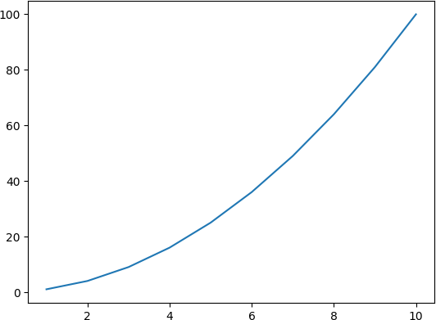

## Example 02

### Add labels and tittle to the graph

In [29]:

**import** numpy **as** np

**import** matplotlib.pyplot **as** plt

x **=** np**.**array((1,2,3,4,5,6,7,8,9,10))

y **=** x**\*\***2 print(x)

plt**.**plot(x,y)

plt**.**xlabel('x-axis') plt**.**ylabel('y-axis') plt**.**title("y = x^2") plt**.**show()

[ 1 2 3 4 5 6 7 8 9 10]

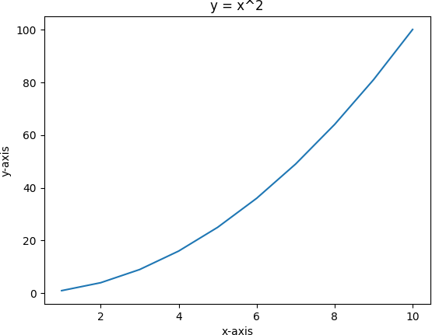

## Exampel 03

### Plot 3 variables on a single graph

In [31]:

**import** numpy **as** np

**import** matplotlib.pyplot **as** plt

x **=** np**.**array((1,2,3,4,5,6,7,8,9,10))

y **=** x**\*\***2 z **=** x **+** 4

print(f"{x}\n{y}\n{z}") plt**.**plot(x,x)

plt**.**plot(x,y)

plt**.**plot(x,z)

plt**.**xlabel('x-axis') plt**.**ylabel('y-axis')

plt**.**title("Plotting the x, y adn z") plt**.**show()

|  |  |  |  |  |  |  |
| --- | --- | --- | --- | --- | --- | --- |
| [ | 1 2 | 3 | 4 | 5 6 7 | 8 | 9 10] |
| [ | 1 | 4 | 9 | 16 25 | 36 | 49 64 81 100] |
| [ | 5 6 | 7 | 8 | 9 10 11 | 12 | 13 14] |

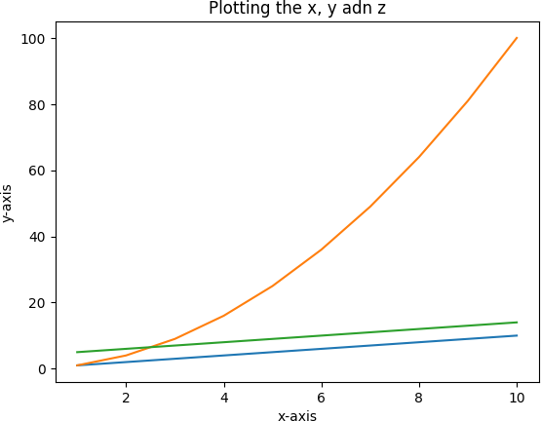

## Example 04

### Change the color linestyle and linewidth of the graph

In [6]:

**import** numpy **as** np

**import** matplotlib.pyplot **as** plt

x **=** np**.**array((1,2,3,4,5,6,7,8,9,10))

y **=** x**\*\***2 z **=** x **+** 4

print(f"{x}\n{y}\n{z}") plt**.**plot(x,x)

plt**.**plot(x,y, color**=**'g', linestyle **=** ':', linewidth**=**15)

plt**.**plot(x,z)

plt**.**xlabel('x-axis') plt**.**ylabel('y-axis')

plt**.**title("Plotting the x, y adn z") plt**.**show()

|  |  |  |  |  |  |  |
| --- | --- | --- | --- | --- | --- | --- |
| [ | 1 2 | 3 | 4 | 5 6 7 | 8 | 9 10] |
| [ | 1 | 4 | 9 | 16 25 | 36 | 49 64 81 100] |
| [ | 5 6 | 7 | 8 | 9 10 11 | 12 | 13 14] |

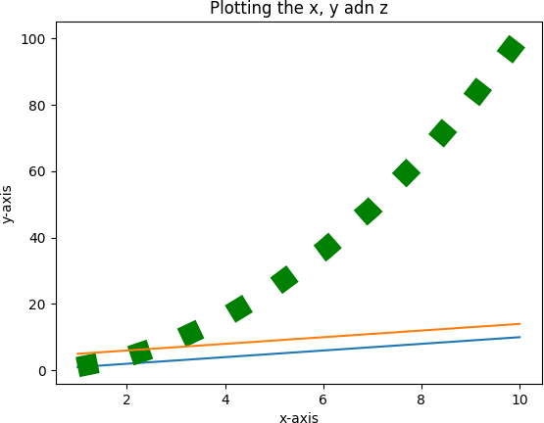

## Example 05

### Plot using subplot

In [10]:

**import** numpy **as** np

**import** matplotlib.pyplot **as** plt

x **=** np**.**array((1,2,3,4,5,6,7,8,9,10))

y **=** x**\*\***2 z **=** x **+** 4

print(f"{x}\n{y}\n{z}")

plt**.**figure(figsize**=**(10,5)) plt**.**subplot(1,3,1)

plt**.**plot(x,x)

plt**.**subplot(1,3,2)

plt**.**plot(x,y, color**=**'g', linestyle **=** ':', linewidth**=**15)

plt**.**subplot(1,3,3) plt**.**plot(x,z)

plt**.**xlabel('x-axis') plt**.**ylabel('y-axis')

plt**.**title("Plotting the x, y adn z") plt**.**show()

|  |  |  |  |  |  |  |  |  |
| --- | --- | --- | --- | --- | --- | --- | --- | --- |
| [ | 1 2 | 3 | 4 | 5 6 7 | 8 | 9 10] |  | |
| [ | 1 | 4 | 9 | 16 25 | 36 | 49 64 | 81 | 100] |

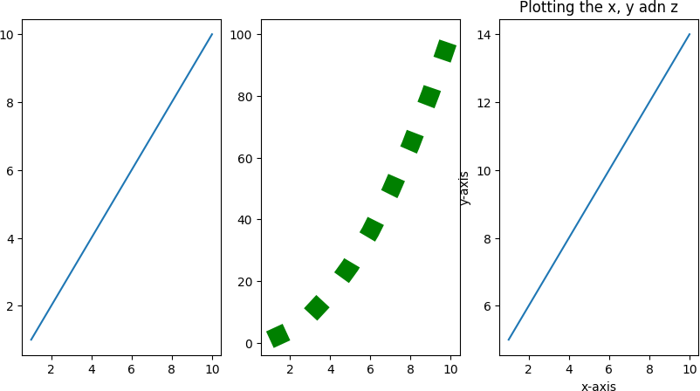[ 5 6 7 8 9 10 11 12 13 14]

## Example 06

### Print the marks of students w.r.t their names using Dictionary

In [14]:

stuMarks **=** {"Ali": 25, "Bilal": 20, "Zahra": 19, "Qayyum": 25, "Alia": 15, "Salman": print(stuMarks)

k **=** stuMarks**.**keys()

v **=** stuMarks**.**values()

plt**.**title("Student Marks") plt**.**xlabel("Names")

plt**.**ylabel("Marks") plt**.**bar(k,v)

plt**.**show()

{'Ali': 25, 'Bilal': 20, 'Zahra': 19, 'Qayyum': 25, 'Alia': 15, 'Salman': 23}

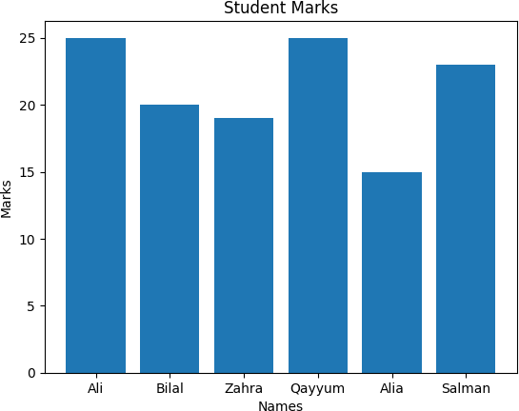

## Example 07

### Plot horizonatal bar garaph

In [16]:

stuMarks **=** {"Ali": 25, "Bilal": 20, "Zahra": 19, "Qayyum": 25, "Alia": 15, "Salman": print(stuMarks)

k **=** list(stuMarks**.**keys())

v **=** list(stuMarks**.**values())

plt**.**title("Student Marks") plt**.**xlabel("Names")

plt**.**ylabel("Marks")

plt**.**barh(k,v) plt**.**show()

{'Ali': 25, 'Bilal': 20, 'Zahra': 19, 'Qayyum': 25, 'Alia': 15, 'Salman': 23}

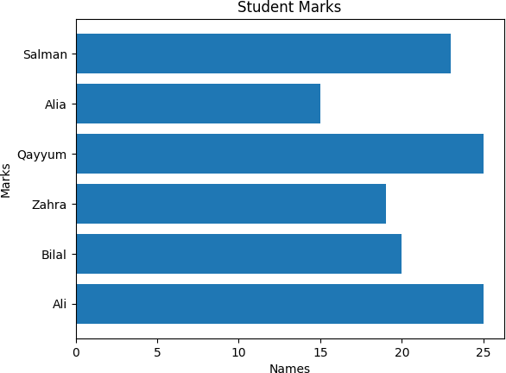

## Example 08

### Bold the tittle and xlabel y label and also show the value of yaxis on top of bars

In [20]:

**import** matplotlib.pyplot **as** plt

stuMarks **=** {"Ali": 25, "Bilal": 20, "Zahra": 19, "Qayyum": 25, "Alia": 15, "Salman": print(stuMarks)

k **=** stuMarks**.**keys()

v **=** stuMarks**.**values()

plt**.**figure(figsize**=**(8, 6)) *# Set the figure size # Plot the bar chart*

plt**.**bar(k, v)

*# Customize the plot*

plt**.**title("Student Marks", fontweight**=**"bold") *# Make the title bold*

plt**.**xlabel("Names", fontweight**=**"bold") *# Make xlabel bold*

plt**.**ylabel("Marks", fontweight**=**"bold") *# Make ylabel bold*

*# Annotate the values on top of the bars*

**for** key, value **in** stuMarks**.**items():

plt**.**text(key, value **+** 0.5, str(value), ha**=**'center', va**=**'bottom', fontweight**=**'bold

plt**.**show()

{'Ali': 25, 'Bilal': 20, 'Zahra': 19, 'Qayyum': 25, 'Alia': 15, 'Salman': 23}

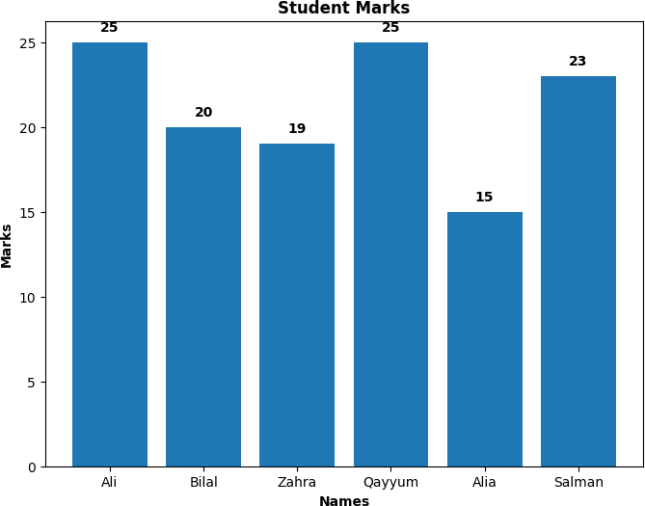

## Example 09

### Plot using scatter function

In [23]:

**import** matplotlib.pyplot **as** plt

stuMarks **=** {"Ali": 25, "Bilal": 20, "Zahra": 19, "Qayyum": 25, "Alia": 15, "Salman": print(stuMarks)

k **=** stuMarks**.**keys()

v **=** stuMarks**.**values()

plt**.**scatter(k,v, color **=** 'r', marker**=**"*", s **=** 40) plt**.**show()

{'Ali': 25, 'Bilal': 20, 'Zahra': 19, 'Qayyum': 25, 'Alia': 15, 'Salman': 23}

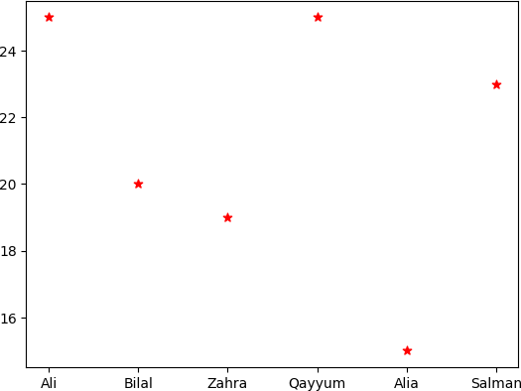

## Example 10

### Plot a histogram

In [27]:

a **=** [1,2,3,4,5,6,7,8,9,4,6,8,2,3,1,1,6,8,9,3,4,2,1,1,2,3,4,5,7]

plt**.**hist(a, bins**=**20, color**=**'g') plt**.**show()

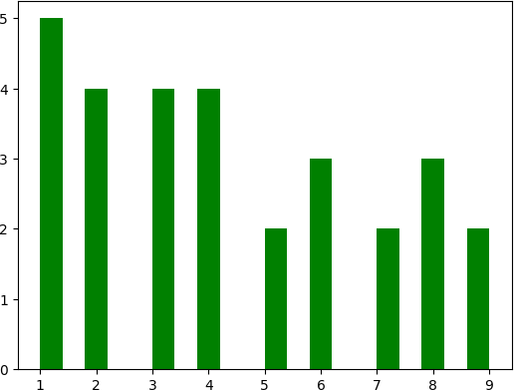

## Example 11

### Demonstrate the use of Box Plot

A Box Plot is also known as Whisker plot is created to display the summary of the set of data values having properties like minimum, first quartile, median, third quartile and

### maximum. In the box plot, a box is created from the first quartile to the third quartile, a vertical line is also there which goes through the box at the median. Here x-axis denotes the data to be plotted while the y-axis shows the frequency distribution.

In [28]:

l1 **=** [1,2,3,4,5,6,7,8,9,10]

l2 **=** [3,4,5,6,7,1,2,8,9,1]

l3 **=** [1,2,3,4,1,2,3,4,5,6]

data **=** list([l1,l2,l3]) plt**.**boxplot(data)

plt**.**show()

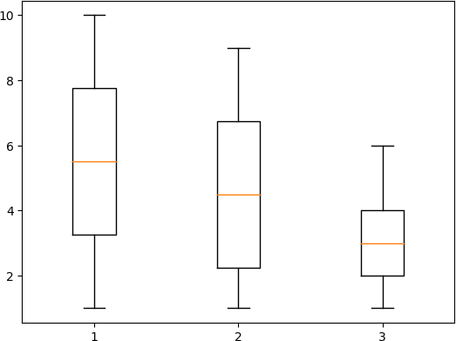

## Example 12

### Demonstrate the use of violin plot

In [30]:

l1 **=** [1,2,3,4,5,6,7,8,9,10]

l2 **=** [3,8,9,6,7,1,2,8,9,1]

l3 **=** [1,2,3,4,1,2,3,4,5,6]

data **=** list([l1,l2,l3]) plt**.**violinplot(data)

plt**.**show()

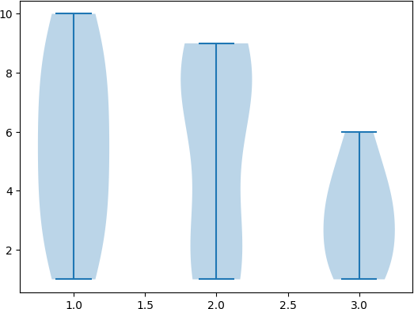

## Example 13

### Show the example of pie plot

In [33]:

**import** matplotlib.pyplot **as** plt

stuMarks **=** {"Ali": 25, "Bilal": 20, "Zahra": 19, "Qayyum": 25, "Alia": 15, "Salman": print(stuMarks)

k **=** stuMarks**.**keys()

v **=** stuMarks**.**values()

plt**.**pie(v,labels**=**k, autopct**=**'%1.1f%%', startangle**=**140) plt**.**axis('equal')

plt**.**show()

{'Ali': 25, 'Bilal': 20, 'Zahra': 19, 'Qayyum': 25, 'Alia': 15, 'Salman': 23}

